**Huawei ICT Competition 2024-2025 Middle East & Central Asia**

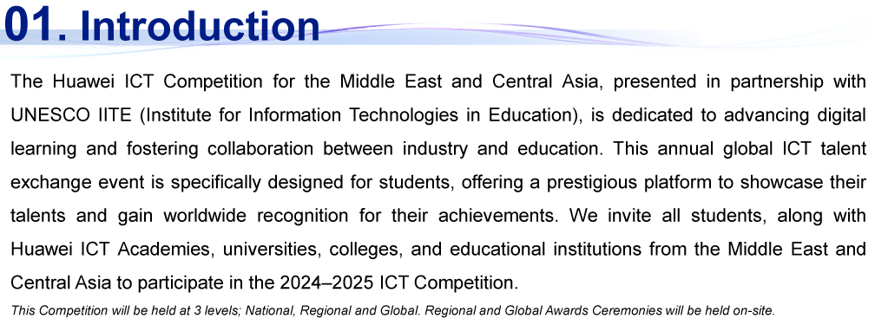

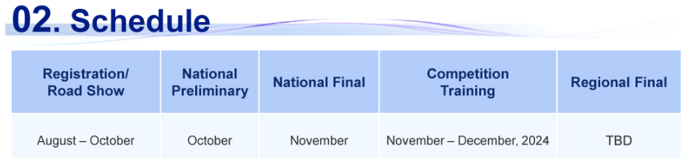

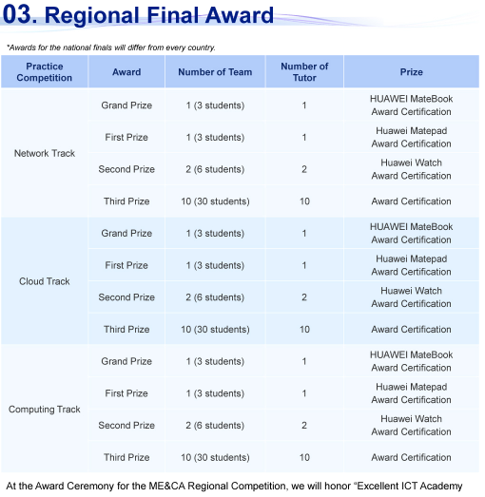

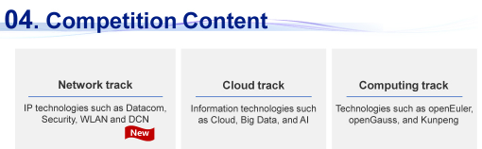

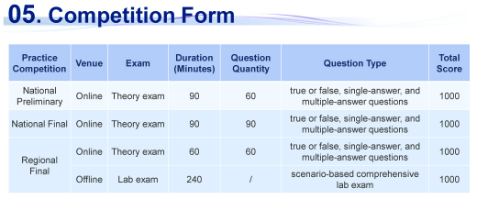

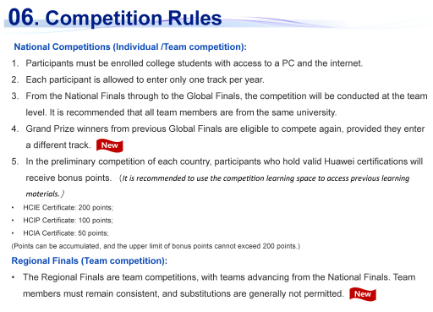

**07. Eligibility Criteria**

**All the students currently studying Advanced Diploma and B.Tech (Cyber and Information Security, and Software Engineering Specialization are eligible to enroll.**

|  |  |
| --- | --- |
| **Specialization** | **Competition Track** |
| Cyber and Information Security | Network Track |
| Software Engineering | Cloud Track |

**08. Registration Deadline**

**The deadline for registration is 30 Sep 2024**

**09. Contact Person**

**Contact Mr. Abdul Basith or Mr. Sathya for more information**

**Email: mohammad.basith@utas.edu.om**

**sathyanarayana.thirunagari@utas.edu.om**